**PHP website creation**

**Final project Documentation**

Csc 368-SPL

tippa2

DEC-04th-2016

1.Enter the url as shown below

<https://uisacad5.uis.edu/tippa2/railwayhomepage.php>

it displays the window as shown below

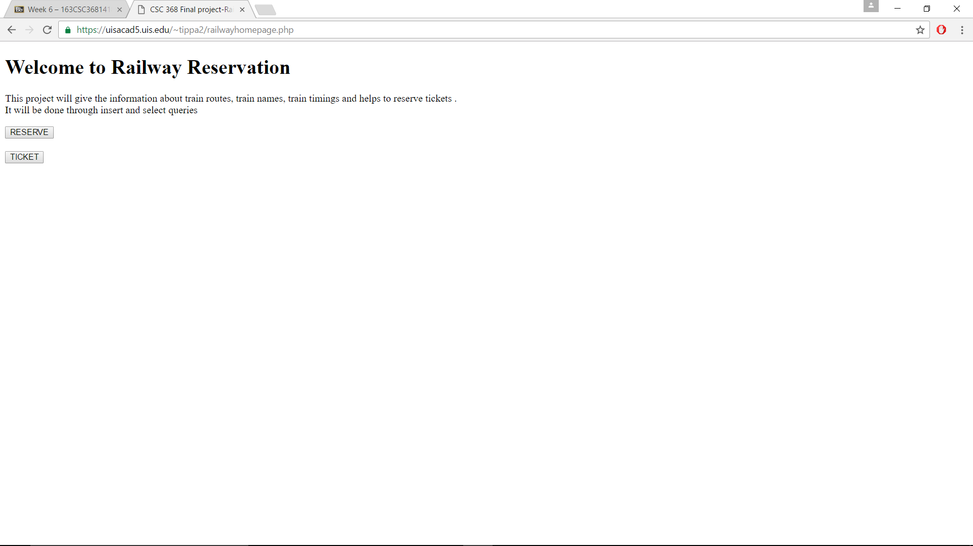

2.now click on the reserve button to fill the passenger details.it will display the window as shown:

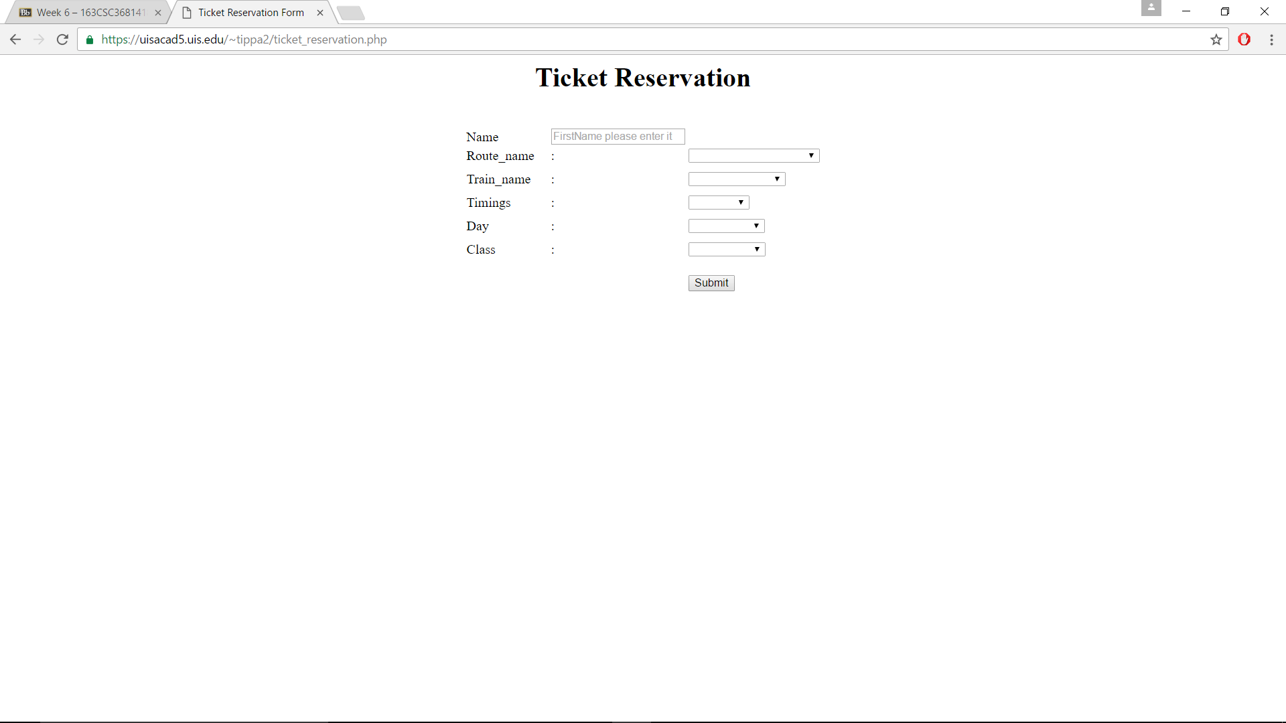

3.now fill the details in the form and click on the submit button as shown:

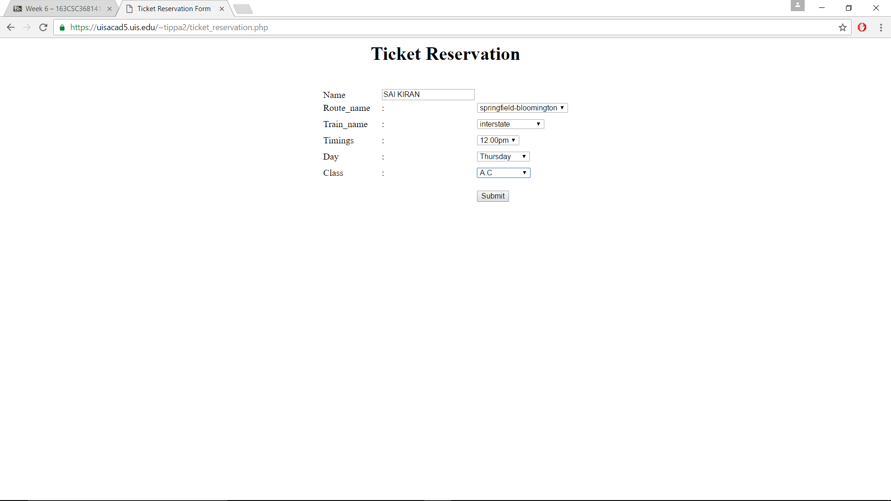

4.it will show the message as reservation successfull, then click on the home button it will direct to the home page as shown:

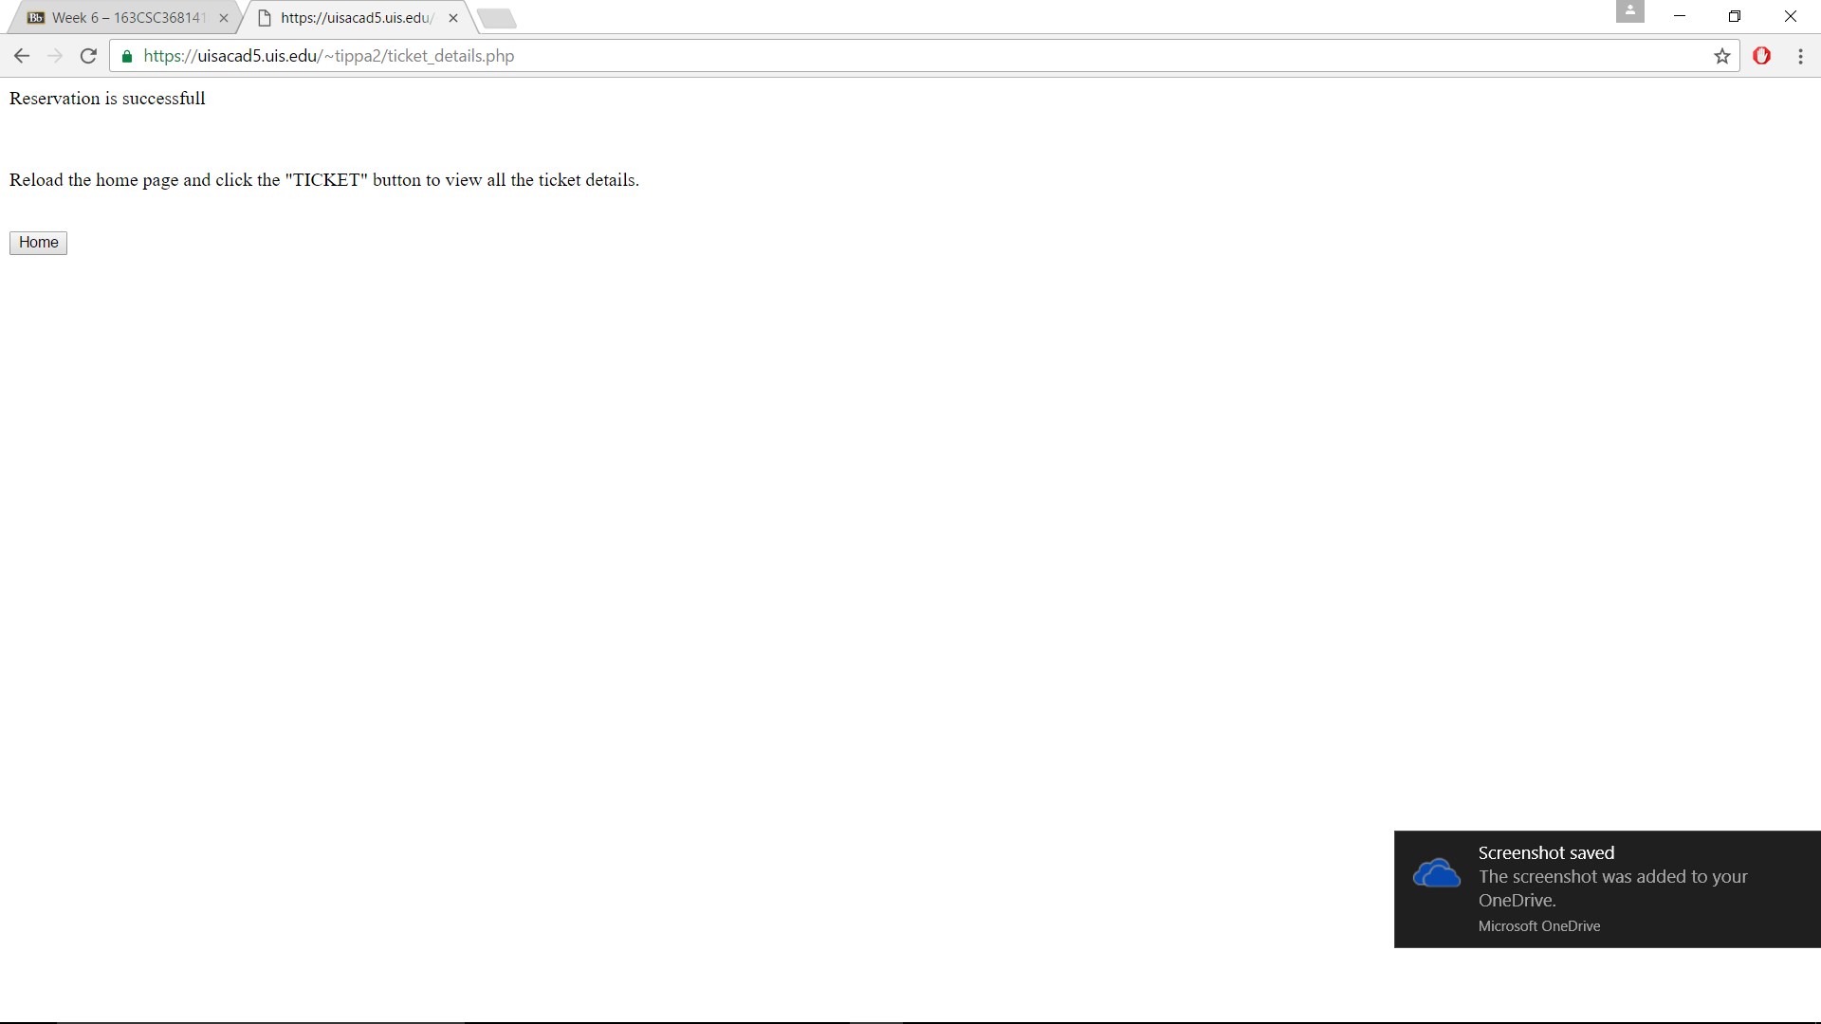

5. now click on the ticket button to know the details of ticket generated

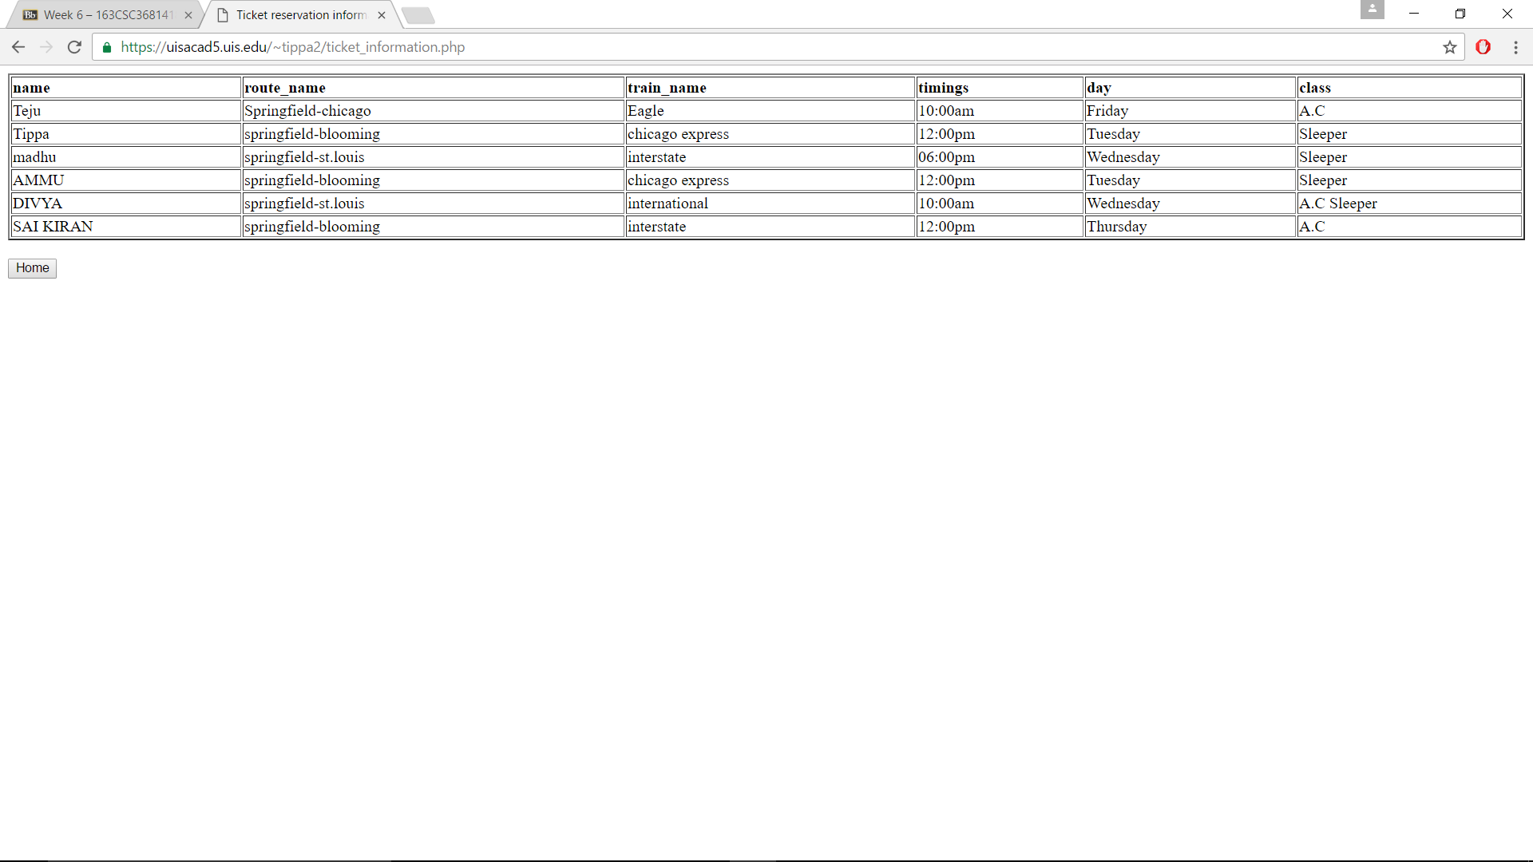

ALGORITHM:

1. With the help of the mysql database php website is designed by using the programs ticket_reservation.php,ticket_information.php,ticket_details.php,railwayhomepage.php
2. In the homepage by clicking on the RESERVE button it will display the ticket information form to fill the passenger details.
3. By clicking on submit button with the help of mysql database we get rows and columns to create the table and insert the values into the table.
4. By clicking on ‘TICKET’ button on the home page we get the details of the tickets that are reserved in the form of a table.